PT STICKER

**Photodynamic Therapy (PDT) Referral/Booking Form**

Date: …………………………………………………………………………………

From: Dr………………………………………………………………………………

Patient details including contact number: ………………………………………..

…………………………………………………………………………………………

**DIAGNOSIS AND SITE (IN FULL)**

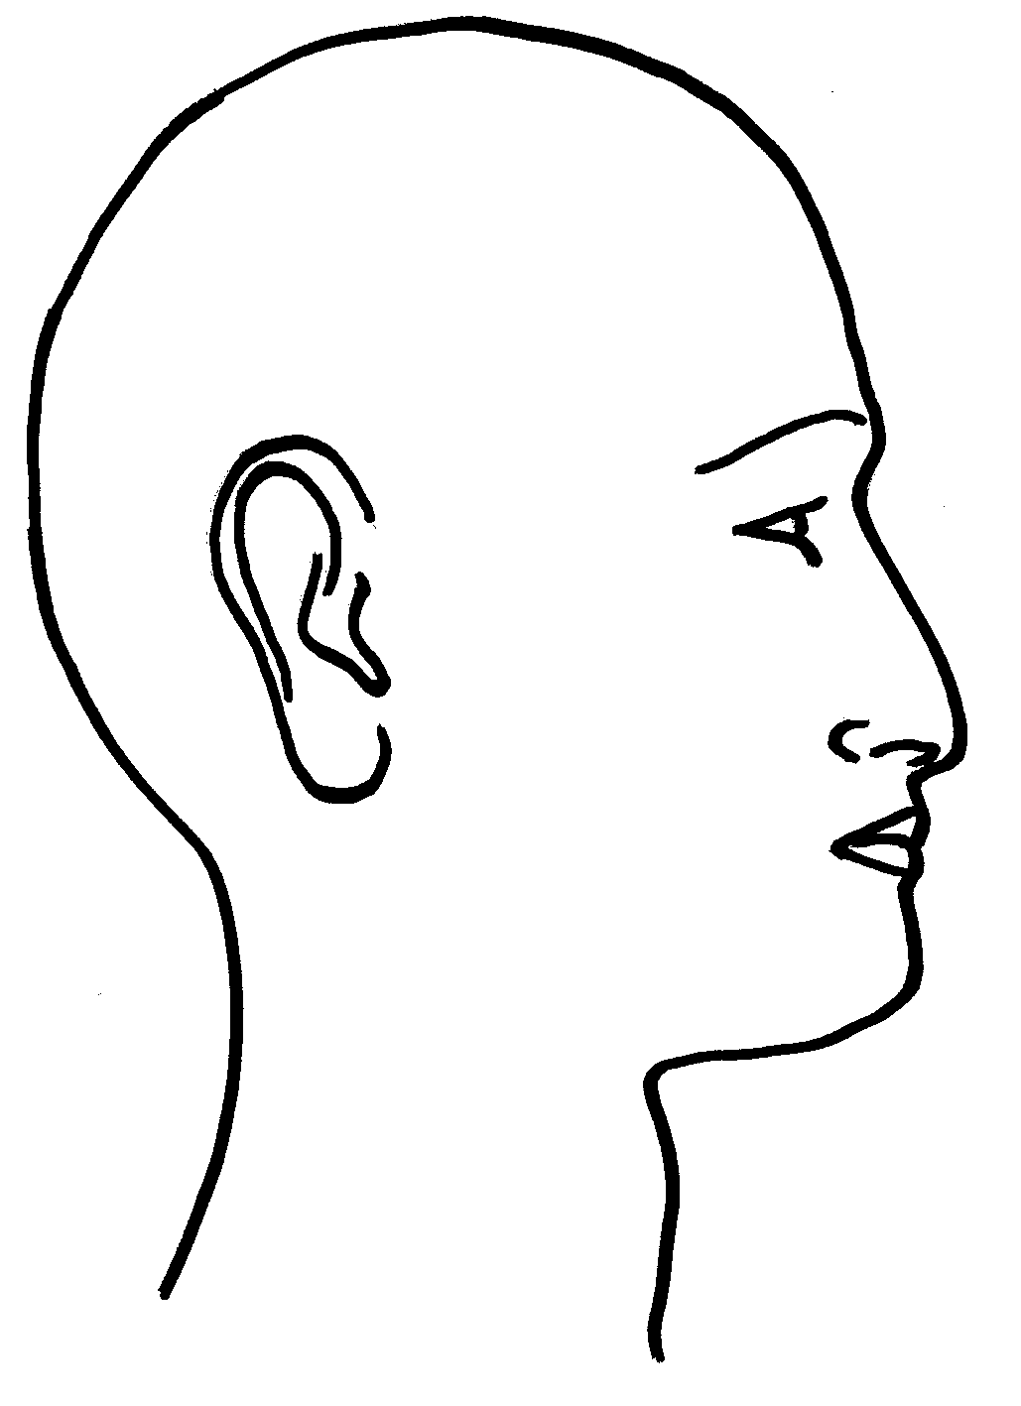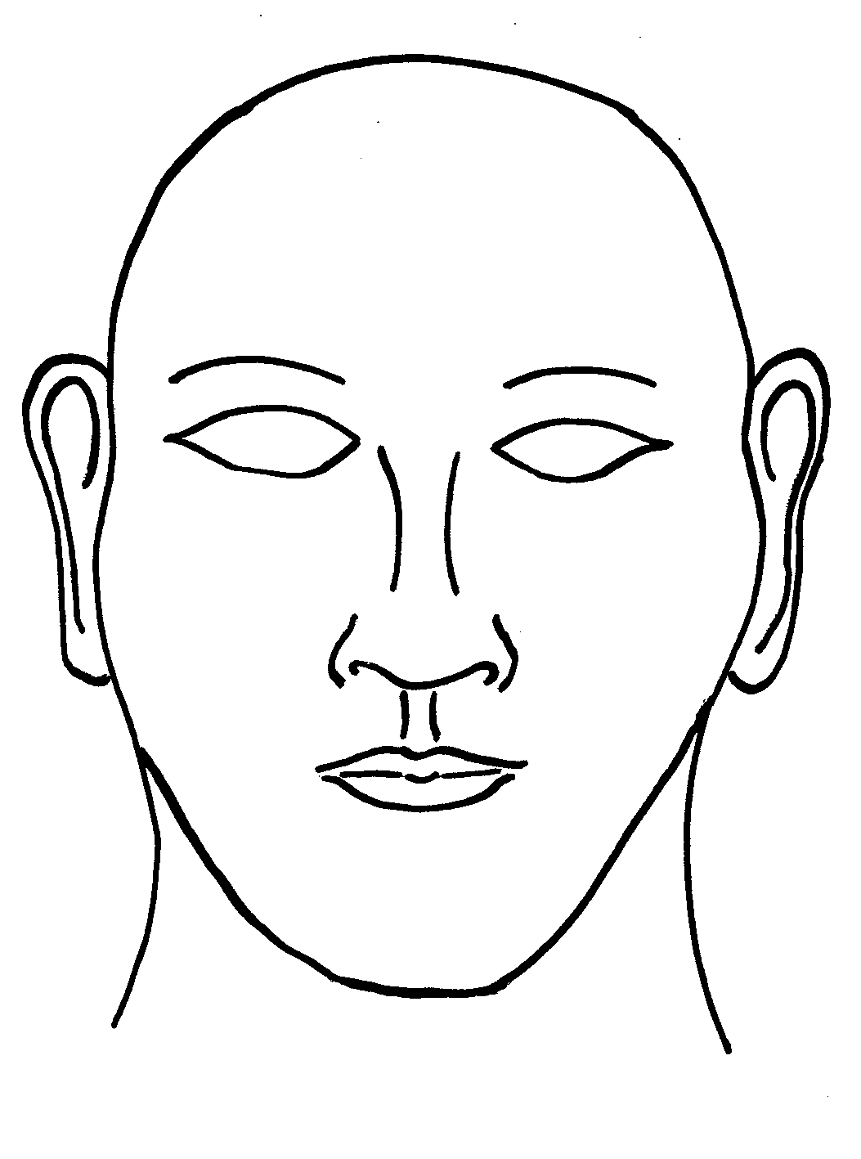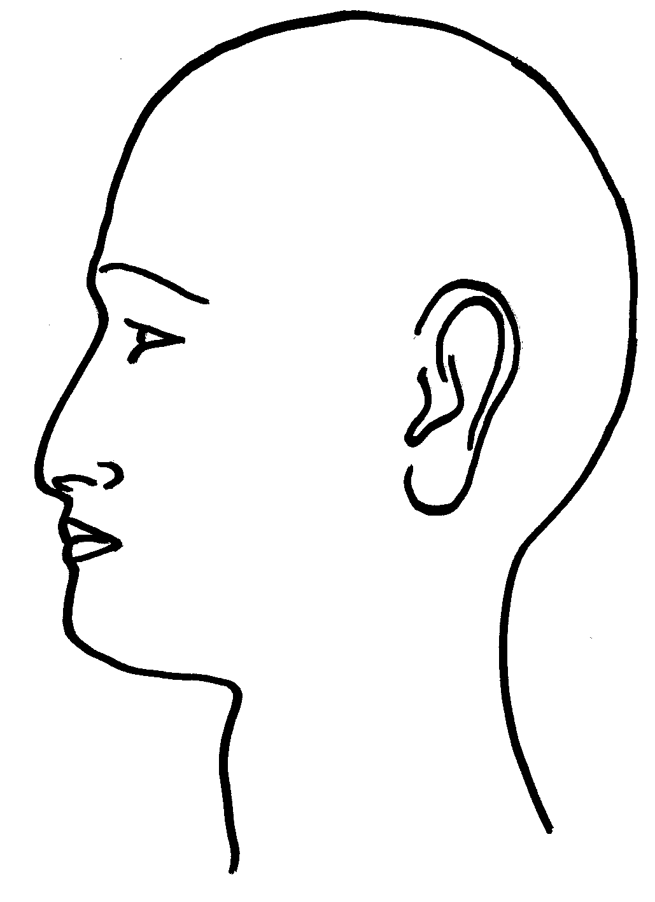

Front Back

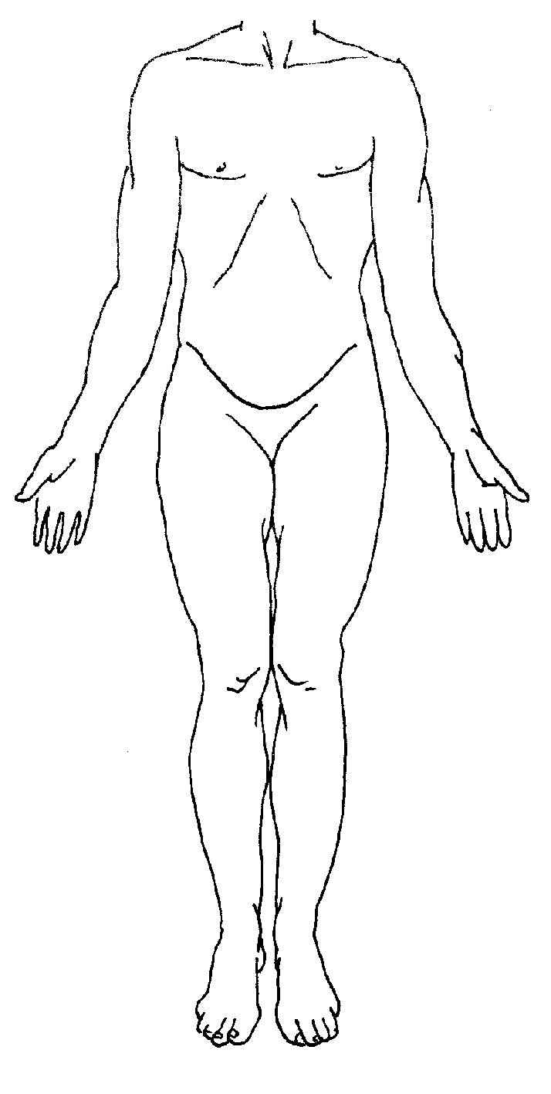 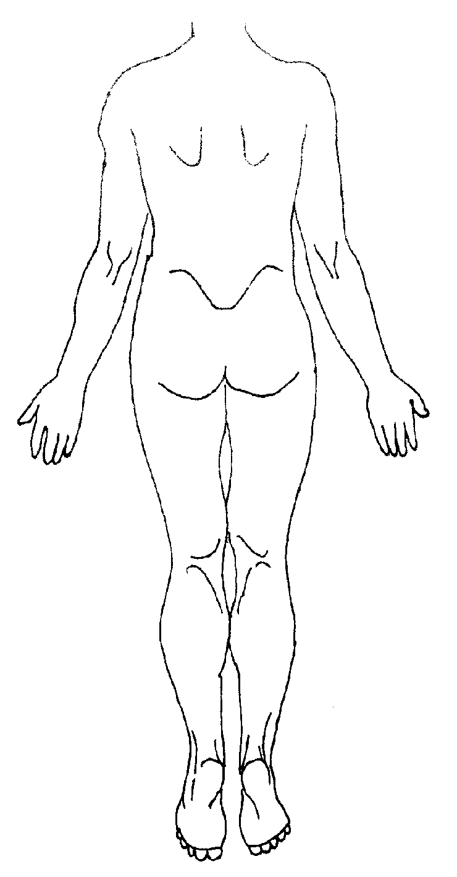

|  |  |  |  |  |
| --- | --- | --- | --- | --- |
| **Skin**  **Diagnosis** | **Site of lesion(s)**  **Please state** | **1st Cycle**  **Please tick ✓** | **2nd cycle**  **Please tick** | **Histologically proven please tick ✓** |
| Actinic Keratosis |  |  | *Not required unless directed* |  |
| Bowen’s disease (SCC *in situ*) |  |  |  |  |
| Superficial Basal cell carcinoma (BCC) |  |  |  |  |
| Nodular Basal cell  Carcinoma (NBCC) |  |  |  |  |

|  |
| --- |
| **To prepare the patient:** If appropriate, the patient can apply Vaseline to the  area to be treated for 2 or 3 days before treatment. This can help preparation  of the skin by removing crust and scale. |

**Number of PDT sessions required:**

For Bowens disease and BCCs – each site should receive two PDT treatments

ideally one week apart.

For AKs – one PDT treatment for each site is sufficient, with no time limit between

treatment of different sites.

Any known allergies…………………………………………………………………………………

**Doctor completing form (please print) ……………………………………………….**