The Gender Pay Gap

Introduction

Organisations with 250 or more employees are mandated under the Equality Act 2010 (Gender Pay Gap Information) Regulations 2017 to publish information annually on their gender pay gap using specific measures, as detailed in this report.

The gender pay gap is the difference between average hourly earnings (excluding overtime) of men and women as a proportion of men’s average hourly earnings (excluding overtime). The gender pay gap is a measure across all jobs in the hospital, not of the difference in pay between men and women for doing the same job.

The intention of pay gap reporting is to focus attention on the evidence for taking action to reduce pay inequality, improve staff experience, retention and make Queen Victoria NHS Foundation Trust (QVH) a great place to work.

The gender pay gap report is a snapshot as at 31 March 2023.

As at 31 March 2023, QVH employed 1,127 people in full time and part time positions compared to 2022, where there were 1,100 staff. For the purposes of this report, electronic staff record (ESR) data has been used to undertake this analysis, and therefore it is dependent on staff reporting their gender via ESR self-service. There were no gaps in the reporting of gender this year.

Methodology

Gender pay gap reporting is based on the government’s methodology for calculating the difference in pay between full-pay relevant female and male employees.
‘Relevant employees’ are all employees employed on the snapshot date, including employees who are part-time, job-sharing, on leave, and those who are self-employed, where they must perform the work themselves and not subcontract any part of the work or employ their own staff to do it.
‘Full-pay relevant employees’ refers to all employees employed on the snapshot date who are either paid their usual full basic pay or paid less than their usual basic pay but not because of leave (for example, because they have irregular working hours). It does not include anyone who was not paid their usual full basic pay because they were on leave (including maternity, paternity, adoption, parental leave, sick leave, special leave, study leave).
Data on ‘relevant employees’ is used to calculate any gender pay gap in bonus pay. Data on ‘full-pay relevant employees’ is used for all other gender pay gap calculations.
‘Equal pay’ means being paid equally for the same/similar work. The ‘pay gap’ is the difference in the average pay between the two groups.

The report includes information on the:

- Gender distribution of staff by grade
- Gender pay gap
- Bonus gender pay gap
- Gender pay trend since 2017

QVH gender distribution by grade

As of 31 March 2023, QVH’s 1,171 full-pay relevant employees comprised 77% women and 23% men.

The graph below shows the split between Agenda for Change (AfC) and Medical & Dental (M&D) employees.

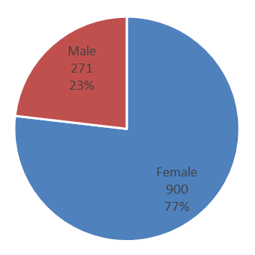
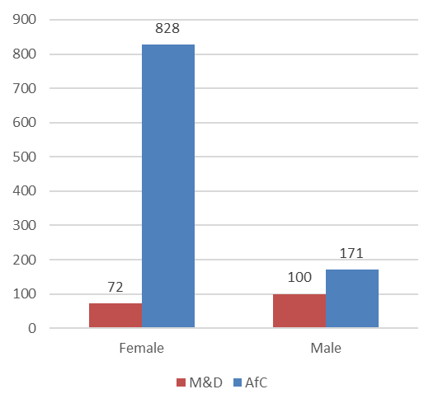
The graph below shows the total headcount and percentage of full-pay relevant employees in each pay band by gender. There are also relevant employees who are on NHS Medical and Dental (M&D) salary scales and executives (VSM). Non-Executive Directors (NEDs) are contracted for services and are included as shown below.
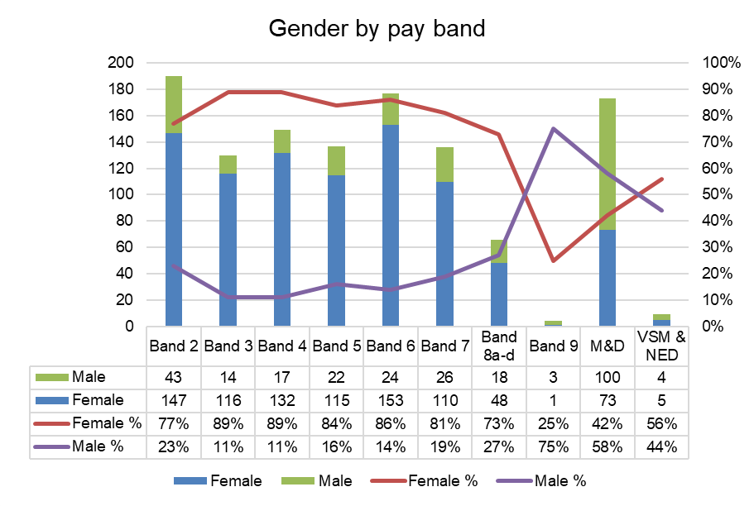
The majority of employees are concentrated in the lower pay bands (2-7). There continue to be more men (58%) than women in medical and dental roles in 2023, although the proportion of women in VSM and NED roles (56%) has increased, compared to 2022 (50%).

QVH gender pay gap

The gender pay gap trend for QVH in the graph below shows improvements made from the previous year in respect of the mean gender pay gap which was 33.8% in March 2023, representing an in-year reduction in the gap by 3.5% percentage points..

The table below demonstrates the same data for all staff groups as in the graph above in terms of the average hourly rates actually paid.

 | 2022 |  | 2023
Gender | Mean average hourly rate | Median average hourly rate | Mean average hourly rate | Median average hourly rate
Male | £29.19 | £23.44 | £29.25 | £24.38
Female | £18.30 | £16.13 | £19.36 | £16.91
Difference | £10.89 | £7.32 | £9.89 | £7.47
Pay Gap % | 37.3% | 31.2% | 33.8% | 30.6%

Gender pay gap – Agenda for Change (AfC) workforce

In respect of Agenda for Change (AfC) staff (excluding Executives, Non-Executives and Medical & Dental), the mean pay gap was 10.1%, a gap of £1.94 an hour in favour of men, because there are more men in higher paid roles. The median pay gap was 8.4%, a gap of £1.41 an hour in favour of men, because there are more men in higher paid roles.

Agenda for Change Staff
Gender | Mean average hourly rate | Median average hourly rate
Male | £19.23 | £16.84
Female | £17.29 | £15.43
Difference | £1.94 | £1.41
Pay Gap % | 10.1% | 8.4%

Gender pay gap – Medical and Dental (M&D) workforce

With regard to Medical and Dental (M&D) staff, the mean pay gap was very significant at 14.1%, a gap of £6.25 an hour in favour of men. The median pay gap was even more significant at 31.3%, a gap of £15.35 an hour in favour of men. This is expected given there are a higher percentage (77.3%) of men in the M&D consultant workforce.

Medical & Dental Staff
Gender | Mean average hourly rate | Median average hourly rate
Male | £44.28 | £49.10
Female | £38.03 | £33.75
Difference | £6.25 | £15.35
Pay Gap % | 14.1% | 31.3%

Proportion of men and women in each pay quartile

Overall at QVH, women occupied 56.3% of the highest paid jobs (upper quartile). However, most (86.0%) employees in QVH in lower quartile (lowest paid) jobs were women, reflecting that male employees were more highly represented in higher paid jobs.

 | Quartile | Total women | Total men | Women | Men
1 | Lower | 251 | 41 | 86.0% | 14.0%
2 | Lower middle | 242 | 51 | 82.6% | 17.4%
3 | Upper middle | 243 | 50 | 82.9% | 17.1%
4 | Upper | 165 | 128 | 56.3% | 43.7%
 | Total | 901 | 270 | 77.0% | 23.1%

The table above and graph below illustrate the gender distribution of the workforce across four quartiles. The proportion of males and females in each quartile, from the lowest to the highest paid, is calculated by dividing the workforce into four equal parts. The first three quartiles contain a higher percentage of women (81.69%) than men (52.59%). There is a higher percentage of men (47.41%) in the upper quartile than women (18.31%).
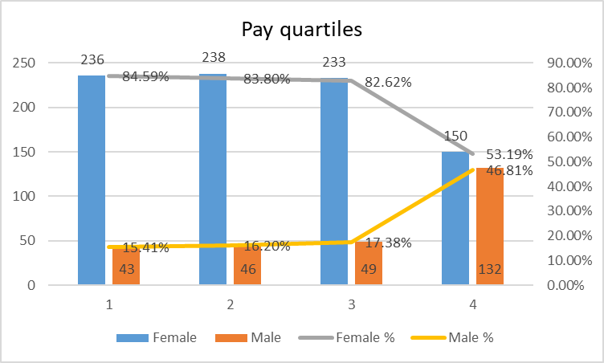

Comparing these quartiles suggests the lower proportion of men in lower pay bands relative to their share of the population (52.59%) was a key driver of the AfC gender pay gap in QVH.

QVH bonus gender pay gap

Bonus payments - overall workforce

In 2023, QVH made bonus payments in respect of the national and local Clinical Excellence Awards (CEAs) for medical and dental consultants, and new starter premium for Agenda for Change staff.

Of the 1,296 relevant employees, 116 received bonus payments which equates to 2.6% of women and 6.3% of men of the overall workforce.

The bonus payments totalled £786,014.91; of which 70.6% was awarded to men and 29.4% to women. In 2023 the mean bonus gender pay gap for the entire workforce was 25.5% and the median bonus gender pay gap was 44.6%. The main contributor to this was the historic distribution of CEA awards within the Medical Consultant body; in spite of the equal distribution of payments since 2021; where the majority of the workforce is male (59 male, 27 female).

Pro-rata bonuses received by part-time employees are not adjusted for the purpose of the gender bonus gap calculations, this impacts the gender pay bonus gap.

Gender | Mean Total Bonus | Median Total Bonus
Male | £7,322.60 | £6,806.85
Female | £5,457.70 | £3,773.85
Difference | £1,864.89 | £3,033.00
Pay Gap % | 25.5% | 44.6%

Bonus payments – Agenda for Change workforce

In the year 2022-3 the Trust offered a new starter premium payments to AfC staff who referred a candidate subsequently employment. The value of this bonus totalled £10,000.00; of which 95% was awarded to females and 5% to males. These payments were paid to a total of 10 individuals.

Gender | Mean Total Bonus | Median Total Bonus
Female | £1,055.56 | £1,500.00
Male | £500.00 | £500.00
Difference | £555.56 | £1,000.00
Pay Gap % | 47.4% | 33.3%

Bonus payments – Consultant workforce

There are 86 consultants in the workforce at QVH; of which 27 (22.7% of the consultant workforce) are women and 59 (77.3%) are men. Considerably more men (n=55) compared to women (n=20) received bonus payments in the form of Clinical Excellence Awards (CEA’s) awarded by the Trust.

CEA payments totalled £776,014.91. The mean (4.9%) was in favour of men who on average received £364.35 more in bonuses than women. The median was 0.0% which can be attributed to the Local CEA payments being equally distributed to all eligible consultants in 2023.

Gender | Mean CEA | Median CEA
Male | £7,406.83 | £6,806.85
Female | £7,042.48 | £6,806.85
Difference | £364.35 | £0.00
Pay Gap % | 4.9% | 0.0%

Gender pay trend since 2017

At QVH we have been reporting our gender pay gap since 2017, for both mean and median averages. The year on year data below is not directly comparable as before 2022 ‘full pay relevant employees’ was not taken to include bank staff and employees holding more than one post were not counted separately for each post.

 | Gap in Mean average hourly rate | Gap in Median average hourly rate
2017 | 37.1% | 40.6%
2018 | 35.9% | 39.9%
2019 | 34.4% | 27.9%
2020 | 35.9% | 32.1%
2021 | 35.3% | 32.4%
2022 | 37.3% | 31.2%
2023 | 33.8% | 30.6%
7 year effect | -3.3% | -10%

Both the mean and median gender pay gaps have reduced in year. However, the median is regarded as typically the more representative measure of the gap due to the disproportionate effect of medical staff on the mean.

However, the Trust has not been successful in closing the gap. To meet the Trust’s aspiration to close the gender pay gap in a decade, considerable acceleration in progress is required.

Analysis

Overall, the mean gender pay gap for hourly pay at QVH on 31 March 2023 was 33.8% in favour of men and the median was also 30.6% in favour of men.

This difference in hourly pay is driven by:

over representation of women in more junior bands,

over representation of men in more senior AfC and VSM pay bands, and

the majority of staff in our higher paid medical & dental grades are male.

The medical and dental workforce

Of the three main drivers the disproportionate number of men in the medical and dental workforce is key. “Mend the Gap” (2020) an Independent Review into Gender Pay Gaps in Medicine in England conducted by the BMA in 2020 identified that caring and part time working were structural barriers to more women completing their training and becoming consultants. This is particularly the case within surgical specialties and an issue for QVH which is a surgical centre.

The table below demonstrates the slow progress in recent years in recruiting more female consultants.

 | 2017 |  | 2018 |  | 2019 |  | 2020 |  | 2021 |  | 2022
 | Number | % | Number | % | Number | % | Number | % | Number | % | Number | %
Female | 20 | 25 | 18 | 24 | 20 | 27 | 24 | 29 | 25 | 28 | 27 | 27
Male | 59 | 75 | 57 | 76 | 55 | 73 | 58 | 71 | 63 | 72 | 59 | 73

The consequence is unequal pay within our most highly paid staff, compounded by historic CEA bonus payments to a predominately male workforce.

NHS EDI high impact action plan

The new plan requires that all providers develop an action plan to eliminate pay gaps. The recommendations of this are incorporated within the action plan below, which aligns with the Trusts joint EDI and staff survey action plan for 2023-4.

The Trust is also committed to eliminating discrimination, bullying and harassment. In the light of the recent findings of the Independent Working Party on Sexual Misconduct in Surgery (2023), and in the context of QVH as a surgical centre, the Trust is also particularly concerned to address any possibility of sexual misconduct, which is unacceptable in any circumstance and may also impact on the career progression of female surgical trainees, as well as other staff.

2023-2024 Action | Timescale
Establish individual and collective EDI objectives for all executive and non-executive board members  Support the trusts action plan to improve Speak Up and psychological safety for all staff  To review existing and commission new provision for training for managers and all staff to increase cultural competence, civility and a just restorative culture.  To invite expression of interest and training to become an inclusion agent within the workplace  Establish a Trust EDI group as a focus for all our EDI work and to ensure a safe space for conversations on workplace belonging and to review pay gap data and develop further improvements, including:  - widening participation though school and community engagement, to support more diverse recruitment training roles  - analyse of historic trends and potential gender bias at appointment  - barriers to career development and promotion  - promote flexible working for all  To continually review the use of CEA’s to promote positive action and eliminate pay gaps.  Undertake an enquiry into workplace belonging – inc. a specific focus on promoting flexible working, eliminating sexual harassment and discrimination and barriers to career progression  Support staff networks development and growth, including our women’s network  Apply an EDI lens through lived experience to an end-to-end review of our current internal and external recruitment processes  Expand career development opportunities within roles and support internal and external career progression for more staff | October 2023  October 2023  November 2023  November 2023  December 2023  January 2024  January 2024  January 2024  February 2024  March 2024

Definitions

Key word | Definition
Pay gap | Difference in the average pay between two groups.
Mean gap | Difference between the mean hourly rate for female and male employees. Mean is the sum of the values divided by the number of values.
Median gap | Difference between the median hourly rate of pay for female and male employees. Median is the middle value in a sorted list of values. It is the middle value of the pay distribution, such that 50% of employees earn more than the median and 50% earn less than the median.
Mean bonus gap | Difference between the mean bonus paid to female and male employees. Mean is the sum of the values divided by the number of values.
Median bonus gap | Difference between the median bonus pay paid to female and male employees. Median is the middle value in a sorted list of values. It is the middle value of the bonus pay distribution, such that 50% of employees earn more than the median and 50% earn less than the median.
Bonus proportions | Proportions of female employees who were paid a bonus, and the proportions of male employees who were paid a bonus.
Quartile pay bands | Proportions of female and male employees in the lower, lower middle, upper middle and upper quartile pay bands. Quartile is the value that divides a list of numbers into quartiles.
Equal pay | Being paid equally for the same/similar work.
Relevant employees | All employees employed on the snapshot date who are:  - have a contract of employment – including employees who are part-time, job-sharing, and on leave
Full-pay relevant employees | Do not count anyone as a full-pay relevant employee if they were not paid their usual full basic pay or piecework rate because they were on leave. This includes employees on:  - annual leave  - maternity, paternity, adoption, parental or shared parental leave  - sick leave  - special leave  - any other forms of leave (for example, study leave or sabbaticals)

